Metal oxide sensors

Metal oxide (MO) sensors show much promise for sensing volatile organic compounds in the ambient atmosphere. There are many different types commercially available and their rapid response time and sensitivity allow for real-time measurements of compounds at the ppb and ppm level.

The small size of the MO sensor means that they are very versatile and can be used in many different locations:

It has been proposed that an array of metal oxide sensors could be used to monitor the indoor air quality in confined spaces such as offices and houses. If the sensors detect high concentrations of a harmful contaminant, such as benzene or carbon monoxide, a smart ventilation system will begin freshening up the air. Sensor arrays can target specific gases to monitor and provide the most efficient way to ensure the people receive a safe and healthy indoor environment1. A mixture of tin dioxide and silicon dioxide MO sensors, with a gold catalyst have been shown to detect carbon monoxide at typical indoor concentrations .The same study used different tin dioxide sensors ,still with a gold catalyst to detect ambient levels of nitrogen dioxide. Both of these contaminants have detrimental impacts on human health1.

Outdoor air pollution

Selectivity towards target atmospheric gases can be achieved by using a surface dopant, morphology of the sensitive surface and using a chemical filter over the sensor.

Since they work using adsorption of the VOCs onto a microfilm2. The VOC is then oxidized, causing a decrease in the conductivity of the metal oxide film. This change in the conductivity is recorded as a VOC signal. In order for these sensors to work, there must be sufficient amount of oxygen in the air flow, as this then replenishes the oxygen molecules at the metal oxide sensor surface3. They are even cheaper to buy than the PID sensors and can be arranges so that a network of tens, or hundreds of these sensors can be continuously measuring the ambient air at once4. They consume a small amount of power but are highly sensitive to contaminants such as hydrogen sulfide, VOCs and ammonia. The sensors contain a tiny heater, which is typically printed onto the reverse of the alumina substrate5. The total amount of contaminants is monitored, not the individual components, however their small size and ease of operating within ambient conditions ( operating temperature range: -10 to 50 oC, ability to observe 1- 10 ppm concentrations) means that there is a huge potential for these sensors.

Detection limits?

Theses metal oxide sensors have been used to study indoor levels of VOCs, such as ethanol, benzene and formaldehyde. These compounds were detected indoors at trace concentrations, of a few ppb with “temperature cycled operation”6.

Metal oxide semiconductors as chemical gas sensors: gas adsorption leads to charge transfer between the surface of the metal oxide and the chemisorbed oxygen.

ZnO has a large surface area to volume ratio and it is relatively easy to nanostructure the compound using a variety of techniques e.g. radio frequency sputtering, sol-gel and oxidising Zn metal. This makes them simple to prepare.

Often used to investigate ethanol in papers.

Metal oxide sensors rely on surface reactions to detect target gases; different metal oxides will have different responses to the same compounds. Humidity and temperature affect these surface reactions and therefore will effect the sensitivity of the sensor2.

Typically, high amounts of water vapor will decrease the sensors sensitivity, for a number of reasons.

The sensors work by oxidizing species on the surface and the chemisorbed species will donate electrons to the metal oxide, inducing a current. Water molecules will adsorb, but do not become oxidized, instead they react with the adsorbed oxygen and reduce the baseline resistance of the metal oxide surface, decreasing sensitivity. In addition, the water molecules will compete with oxygen molecules (O2) for adsorption sites on the metal oxide surface, and will block the VOC molecules from adsorbing to the surface.

Prolonged exposure to high relative humidity causes OH anions to form on the metal oxide surface. These stable chemisorbed species will lead to a decreased sensitivity which will get increasingly worse, until they are destroyed when the surface is heated to 450 oC2.

Metal oxide sensors have many advantages over other techniques when sampling in the field. The manufacturing method is relatively easy and allows large scale production of lightweight, durable sensors that have a relatively high sensitivity (a few ppb) towards atmospheric constituents7. Typically, the response rate is fast and continuous measuring will allow a good time resolution, and because they are inexpensive many of them can be placed in a network to allow spatial mapping of a region.

How do they work?

Metal oxides are semi-conductors and Band Theory declares that there must be a valence band and a conductance band. The energy gap between these two is small enough that electrons with certain threshold of energy can transition from the lower energy valence band to the conductance band.

Oxygen molecule in the air become adsorbed to the metal oxide surface and the dissociative chemisorption produces oxygen anions and “positive holes”. These ionized species will react with reducing gases, such as VOCs. When this occurs the amount of charge carriers at the metal oxide surface changes, resulting in a alteration of the resistance between the sensors electrodes. This can be measured and translates as a signal. A larger concentration of the reducing gas causes more of a deviation of resistance7.

Within the VOC sensor there is a metal oxide surface which is a semi-conductor formed from a lattice of ions. Therein exists a conductance band and a valence band, as stated by Band Theory.

How do they work?

The key components of every metal oxide sensor consist of:

1. the sensing layer, a lattice of metal and oxygen ions,
2. electrodes
3. substrate.
4. Heater to heat the sensing layer to the operating temperature. For tin dioxide, this is typically around 200- 400 oC.

All have a role to play in detecting target gases. The surface of the lattice is especially important as it can be fine tuned in order to become more sensitive or selective towards particular species of compounds.

Doping the surface with other metals (GIVE EXAMPLES) leads to selectivity towards gases such as carbon monoxide, NOx and ammonia8.

|  |  |  |  |
| --- | --- | --- | --- |
| Senor type | Doped with | Target gas | Limit of detection |
| SnO2 | 0.2 wt% Pd | CO |  |
| SnO2 |  | CO |  |
| In2O |  | NO |  |

Defects, steps and the number of vacancies in the lattice will all influence the behaviour of the metal oxide sensor9.

MOS sensors such as tin dioxide sensors are a more complicated version of a semi-conductor. Tin dioxide is the most commonly used sensitive layer used in metal oxide sensors8,10 and is more specifically an n-type semiconductor with a relatively wide band gap9. N-type semiconductors have electrons being the predominant charge carriers, as there are more electrons located in the conduction band, than “holes” in the valence band.

This means that at energy levels below the Fermi energy, tin dioxide doesn’t conduct electricity, but the band gap is small enough that at room temperature, electrons have enough energy to move into the unoccupied energy levels in the conduction band and tin dioxide conducts electricity.

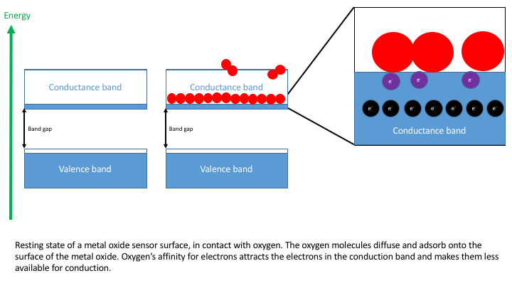

Figure 1 Resting state of a semiconductor such as tin dioxide, in the presence of oxygen.

Oxygen adsorbs onto the surface of the tin dioxide, see figure 1. Since oxygen has a high affinity for electrons the adsorbed ions “pull” electrons out of the conductance band and form negative oxygen ions. This is the resting state of the metal oxide sensor. The reduced number of electrons in the conductance band leads to a decreased resting conductance.

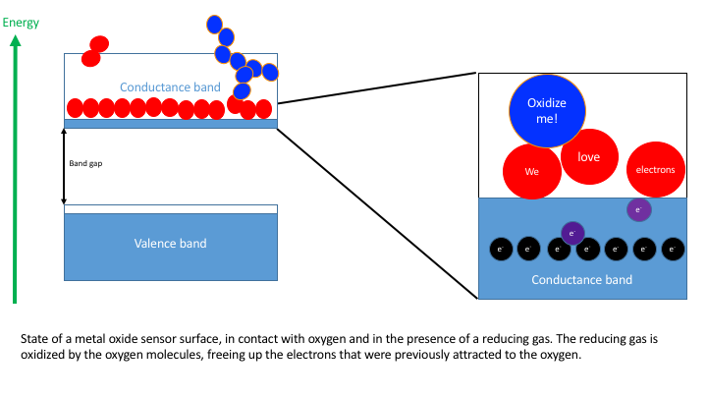

Figure 2 Explanation of how the presence of a reducing gas, such as CO or a VOC causes reactions on the sensor surface. The VOC is oxidized by the oxyanions, and this frees up the electrons previously attracted to the oxygen molecules.

When a reducing gas, such as methane comes into contact with the metal oxide sensor it reacts with the oxyanions and leads to a reduction in the amount of electrons being “pulled” from the conduction band. Reducing gases therefore cause an increase in the conductivity of the surface because there are less oxygen anions to attract electrons. The reduction in the resistance8,7,9 of the sensor can be measured using electrical circuitry7. The negative charges, electrons, determine the overall conductance of the sensing material and any properties that cause a change in the charge carrier distribution. These include :

* surface reactions with gases. When working in atmospheric conditions it is important to be aware of gases other than the target gas that may interact and have a large impact on the conductance. To overcome the problem of interference with gases that are present in high concentrations sometimes a filter is used. A filter of charcoal has been used to remove volatile organic compounds from ambient air, which will affect readings of CO10.
* morphology of the sensing surface, different sensors have different morphologies and this can lead to the sensors being selective towards particular homologous series10,2.
* size distribution of the grains that make up the surface will affect the conductance9.
* Operation temperature will have a large affect on the overall sensitivity of the device10,11.

When working with metal oxide sensors and analyzing the collected data there are certain assumptions that are often made:

1. the reacting gases always react with the chemisorped oxygen anions
2. the concentration of the reacting gas is proportional to the amount of the gas that gets adsorbed9.

Difficulties with using MOS:

If there are large quantities of ozone in the headspace of the sensor, the material will respond differently and will give inaccurate readings7.

Equally, water will affect the conductivity of the material as OH- ions form on the surface ultimately causing smaller response times and greater signals when water is present… 7

Cross sensitivity must be considered as ambient air will contain a mixture of gases. Other common gases must be calibrated for to ensure that signal fluctuations are due to the target gas and not the background. Gases present in very low concentrations maybe OK to neglect as their contribution towards a signal will be negligible8.

Production: Chemical vapor deposition/ physical vapor deposition.

Measuring: CO, CO2, NOx, ammonia

Metal oxide sensors rely on oxygen adsorbed to a reactive surface. An equilibrium is set up, the oxygen molecules can be desorbed, adsorbed to the surface or diffuse into the bulk of the metal oxide. The position of this equilibrium determines the sensitivity of the sensor, and it has been shown that changing ambient temperature affects the conductance of the sensor, effecting the response to a target gas. Following a change to the ambient temperature, there will be a change to the quantity of oxygen vacancies within the metal oxide layer. Conductance is dependent on the number of vacancies as a new equilibrium has to be reached between the oxygen in the bulk and the gas phase11.

Therefore when a dramatic temperature change in the surrounding environment of the sensor occurs it may take a few hours for the sensor to equilibrate before taking readings11.